

***CONTAINERS AND DOCKERS***

***Submitted by:***

***NAME: Tanishqua Tellakula***

***SAP ID: 500084269***

***Roll number :R120220007***

***Batch: B1(Hons)***

***Lab Exercise 6- Create POD in Kubernetes***

***Objective:***

* *Understand the basic structure and syntax of a Kubernetes Pod definition file (YAML).*
* *Learn to create, inspect, and delete a Pod in a Kubernetes cluster.*

***Prerequisites***

* *Kubernetes Cluster: You need a running Kubernetes cluster. You can set up a local cluster using tools like Minikube or kind, or use a cloud-based Kubernetes service.*
* *kubectl: Install and configure kubectl to interact with your Kubernetes cluster.*
* *Basic Knowledge of YAML: Familiarity with YAML format will be helpful as Kubernetes resource definitions are written in YAML.*

***Step-by-Step Guide***

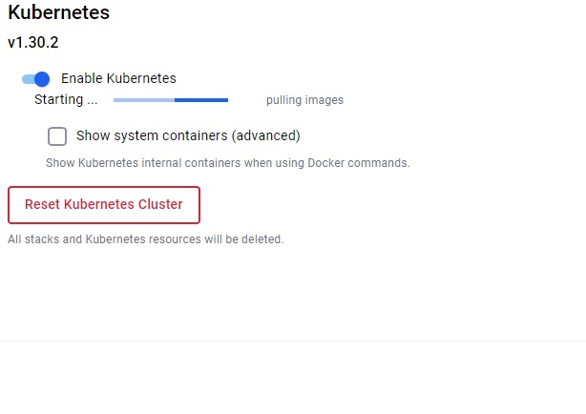

***Step 1: Create a YAML File for the Pod***

*We'll create a Pod configuration file named pod-example.yaml*

|  |
| --- |
| ***apiVersion: v1 # The version of the Kubernetes API to use for this object.***  ***kind: Pod # The type of Kubernetes object. Here it's a Pod.***  ***metadata: # Metadata about the Pod, such as its name and labels.***  ***name: my-pod # The name of the Pod. Must be unique within a namespace.***  ***labels: # Labels are key-value pairs to categorize and organize Pods.***  ***app: my-app # Label to categorize this Pod as part of 'my-app'.***  ***spec: # The specification for the Pod, detailing its containers and other settings.***  ***containers: # List of containers that will run in this Pod.***  ***- name: my-container # The name of the container. Must be unique within the Pod.***  ***image: nginx:latest # The Docker image to use for this container. Here, it's the latest version of Nginx.*** |

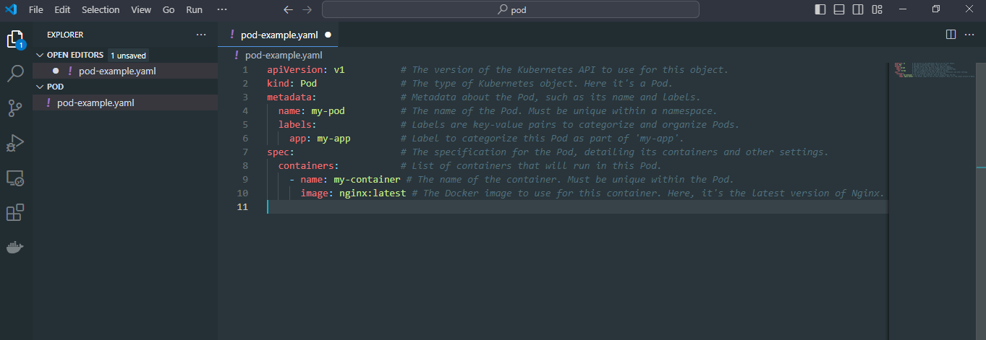

***Explanation of the YAML File***

* *apiVersion: Specifies the version of the Kubernetes API to use. For Pods, it's typically v1.*
* *kind: The type of object being created. Here it's a Pod.*
* *metadata: Provides metadata about the object, including name and labels. The name must be unique within the namespace, and labels help in identifying and organizing Pods.*
* *spec: Contains the specifications of the Pod, including:*
  + *containers: Lists all containers that will run inside the Pod. Each container needs:*
    - *name: A unique name within the Pod.*
    - *image: The Docker image to use for the container.*
    - *ports: The ports that this container exposes.*
    - *env: Environment variables passed to the container.*

***Step 2: Apply the YAML File to Create the Pod***

*Use the kubectl apply command to create the Pod based on the YAML configuration file.*

|  |
| --- |
| ***kubectl apply -f pod-example.yaml*** |



*This command tells Kubernetes to create a Pod as specified in the pod-example.yaml file*

*.*

***Step 3: Verify the Pod Creation***

*To check the status of the Pod and ensure it's running, use:*

|  |
| --- |
| ***kubectl get pods*** |

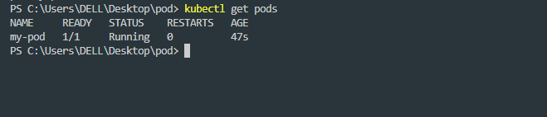

*This command lists all the Pods in the current namespace, showing their status, restart count, and other details.*

*You can get detailed information about the Pod using:*

|  |
| --- |
| ***kubectl describe pod my-pod*** |

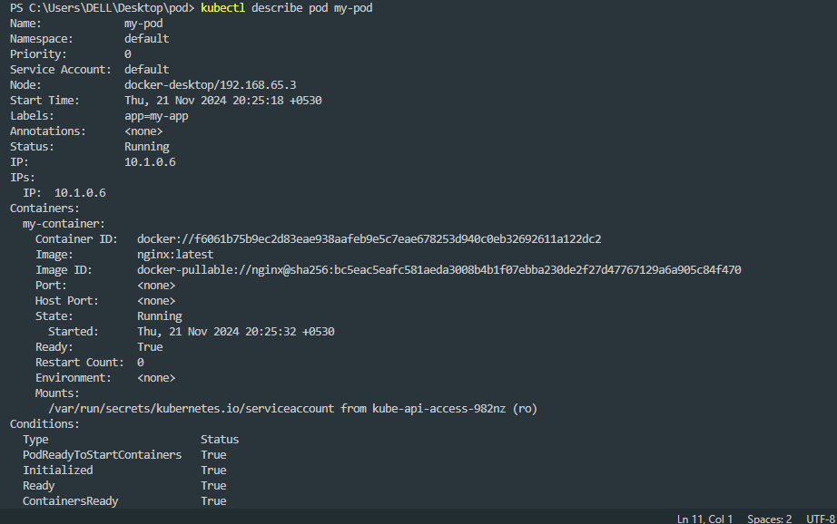

*This command provides detailed information about the Pod, including its events, container specifications, and resource usage.*

***Step 4: Interact with the Pod***

*You can interact with the running Pod in various ways, such as accessing the logs or executing commands inside the container.*

***View Logs: To view the logs of the container in the Pod:***

|  |
| --- |
| ***kubectl logs my-pod*** |

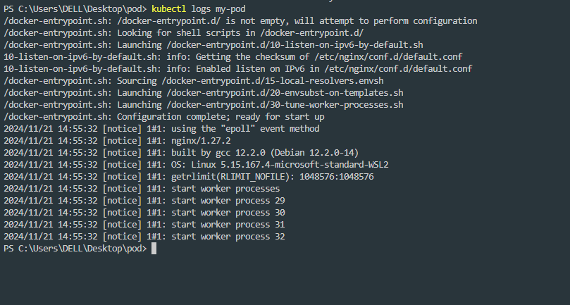

***Execute a Command: To run a command inside the container:***

|  |
| --- |
| ***kubectl exec -it my-pod -- /bin/bash*** |

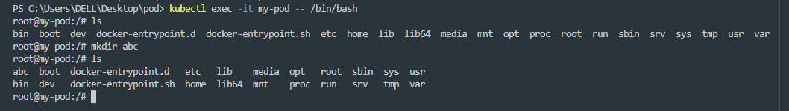



*The -it flag opens an interactive terminal session inside the container, allowing you to run commands.*

***Step 5: Delete the Pod***

*To clean up and remove the Pod when you're done, use the following command:*

|  |
| --- |
| ***kubectl delete pod my-pod*** |

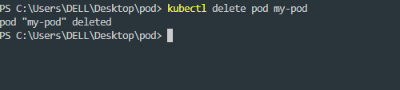

*This command deletes the specified Pod from the cluster.*